Arthroscopic Subscapularis Repair

Indications for Surgery
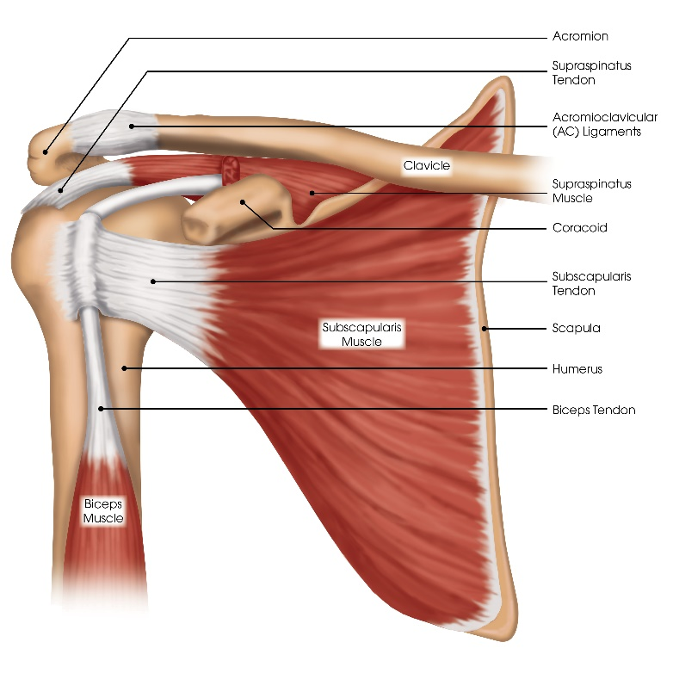
The rotator cuff is a group of four muscles that run from the scapula (shoulder blade) and attach to the humeral head (top of upper arm bone) by their tendons. One of the muscles of the rotator cuff is the subscapularis. The subscapularis muscle runs from the underside of the scapula (shoulder blade) to the front of the humerus (arm bone) and is responsible for internal rotation of the arm. When the rotator cuff is injured, the tendon is typically torn off the humerus (upper arm bone), retracts and cannot heal back on its own. The subscapularis tendon also plays a role in stabilizing the biceps tendon. When the subscapularis tendon is torn, it allows the biceps tendon to dislocate, become unstable, shift, fret like a rope and cause pain.
If left untreated, the biceps may rupture and result in a “Popeye-like” deformity.

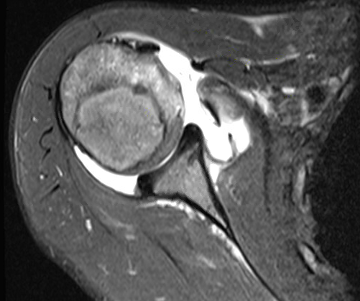
MRI of torn subscapularis tendon with retraction. Red arrow indicates where the subscapularis muscle should be attached to the humerus.

Rotator cuff tears tend to progress and become larger and more symptomatic. Additionally, as time goes by the rotator cuff tendon retracts further and the rotator cuff muscle atrophies (shrinks and weakens) and degenerates (irreversibly turns to useless fat and scar tissue). This makes the repair technically more difficult (potentially not possible) and the rotator cuff becomes less likely to heal and function normally. The goal of surgery is to eliminate the shoulder pain and attempt to regain active motion and strength by reattaching the torn rotator cuff tendon back to the upper arm bone at the shoulder using sutures and anchors placed in the bone.
Illustration of intact subscapularis tendon
Contraindications to Surgery:
- Infection
- Shoulder stiffness
- Inability or unwillingness to complete the postoperative program including immobilizing the shoulder in a sling for six to eight weeks and performing physical therapy three times per week for four to six months
- Patients with poor general health which is not sufficient to proceed with surgery
- Arthritis
- Chronic migration of the humeral head from the glenoid (socket)

Potential Surgical Risks and Complications:
- Infection
- Injury to nerves (numbness, weakness, paralysis) of the shoulder and arm from the nerve block
- Continued or recurrence of pain
- Re-tear of the rotator cuff tendon
- Detachment of the deltoid muscle (if open surgery is performed)
- Stiffness or loss of motion of the shoulder
- Inability to return to the same level of athletics or work
- Persistent weakness of the shoulder
- Late acromioclavicular (AC) joint pain
- Finding an irreparable tear at the time of surgery. Preoperatively, MRI is limited and reparability of the rotator cuff tendon is not always completely predictable. Fortunately, most tears are technically reparable.
- Finding damage to other structures such as the biceps tendon, labrum, and articular cartilage that may require further treatment at the time of surgery.
- Arthritis
- Chronic migration of the humeral head from the glenoid (socket)

Hospitalization and Anesthesia
- Outpatient surgery (you go home the same day)
- General anesthetic with interscalene nerve block (See Your Surgical Experience booklet)

General Surgical Technique
Dr. Chudik approaches rotator cuff tears arthroscopically through small incisions (arthroscopic portals) and can repair the great majority of tears entirely arthroscopically. Dr. Chudik uses small incisions to look in the shoulder joint with a camera and special instruments to repair the rotator cuff and any other problems seen in the joint. Sometimes if the tendon is too far retracted or will not reach the correct attachment site, Dr. Chudik may need to make a small,
open incision to advance and repair the tendon. The rotator cuff tendon is repaired back to the bone of the humerus with anchors into the bone and sutures into the tendon. The sutures and anchors hold the tendon in place until the tendon gradually grows back to the bone in four to six months. Muscle transfers can be performed when the subscapularis is irreparable.

Preoperative Instructions
- Discontinue birth control pills
- Stop blood thinners such as aspirin, Coumadin®, Lovenox®, Xarelto® according to the prescribing doctor’s directions
- Stop anti-inflammatory medicines such as ibuprofen, Advil®, Motrin®, Naprosyn®, Alleve®, etc.
- Stop nutritional supplements and drinks like Vitamin C, ginseng, ginkgo biloba, etc.
- Stop smoking for surgery and during the first six weeks postoperatively to allow proper tissue healing
- Do not eat or drink anything from midnight, the evening before surgery

Post-operative Course
- You will use a sling at all times except for bathing, dressing and exercising for six to eight weeks following surgery, especially while you sleep. This prohibits driving.
- You will not be allowed to actively move your repaired shoulder (moving it with its own shoulder muscles) and possibly your elbow (if the biceps tendon is involved) for at least six to eight weeks following surgery in order to protect the repair and allow healing.
- You may feel more comfortable sleeping sitting upright (on a couch or recliner chair) after surgery.
- Keep the wound clean and dry for three days following all arthroscopic surgery and ten to 14 days following open surgery. You may shower lightly after three days (all arthroscopic) and 14 days (open surgery), but wounds cannot be submerged under water for three weeks.
- Driving after six to eight weeks.
- Return to school/sedentary work in less than one to two weeks as long as you are in your sling and do not use the extremity. No typing, writing or purposeful movement.
- Physical therapy should begin two to three days after surgery and continue for four to six months. The success of rotator cuff repair is highly dependent on the post-operative rehabilitation. It is crucial to follow through on and maintain a proper therapy schedule.

Return to Activity
You may return to unlimited activities when there is no pain and full shoulder range of motion, muscle strength and endurance, and functional use has been restored. This usually requires four to six months following a rotator cuff repair. Dr. Chudik will tell you when it is safe to resume all activities. Dr. Chudik has special protocols for returning to throwing and golf.
Scheduling Surgery
Contact Dr. Chudik’s surgery scheduler at 630-324-0402 or contactus@chudikmd.com to:
- Schedule the date and location of surgery (the hospital will call the day before with the confirmed arrival time)
- Schedule a pre-operative appointment
- Schedule a post-operative appointment to remove sutures and review post-operative instructions

Notify My Office if Symptoms Worsen

